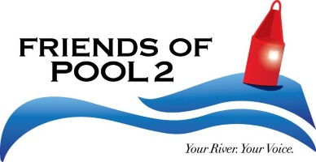

Friends of Pool 2 Board Meeting Minutes
August 18th, 2025
6:00pm – 8:00pm
Jersey’s Bar & Grill, Inver Grove Heights, MN

MINUTES

Attendees
 | Present | Absent |  | Present | Absent
Greg Genz, President | x |  | Linda Michie, Executive Director | x
Steve Buege, Vice President | x |  | Alyssa Stadtler, Admin Assistant | x
Emily Evans, Secretary
Fred Kreider, Treasurer | X
Amanda Drigans
Angel Binner | x
Angelina Moua
Caitlin Monette | X
Charlie Evans
Luke Nilles | x

DISCUSSION
Greg Genz called the meeting to order at 6:02pm
Staffing/Banking/Board of Directors updates:
- Financial summary: checking account balance on 8/18/25 was $ 4,744.89, CD balance was $ 5,166.94 (56.42 int earned), and the PayPal account balance was $215.28
  - Check # 5015 for $ 672.66 (Mississippi Pub) cleared on 8/8 (Annual Meeting Food)
  - Check # 5014 for $ 520 (Alyssa) cleared on 8/8 (July hours)
  - Check # 5013 for $ 45 (Angelina) cleared on 8/7 (July billing)
  - Check # 5012 for $ 110 (Angelina) cleared on 8/7 (May billing)
  - Check # 5011 for $ 30 (Angelina) cleared on 8/7 (June billing)
  - Credit of $ 750 transfer from Linda’s account on 8/5 – repayment of cash withdrawal
  - Withdrawal of $ 750 cash (Linda) on 7/28 for potential purchase of enclosed trailer
  - Charge of $ 101 (ABC Rentals) on 7/24
  - Interest received on 7/23 of $ .48
  - Deposit on 7/22 of $ 140 (cash proceeds from raffle sales)
  - Charge of $ 70.44 (printer) on 7/11 (new table runner)
  - Check # 5010 for $ 525 (Alyssa) cleared on 7/9 (June hours)
  - Deposit of $250 on 7/1 (donation check from One Mississippi)
  - Deposit of $ 225 (checks) on 6/27 for membership renewals from Annual Meeting
  - Interest received on 6/25 of $ .48
  - Deposit of $ 235 (cash) on 6/24 from memberships plus raffle sales at Annual Meeting
  - Charge of $ 101 (ABC Rentals) on 6/24
- Marketing Contractor – Angelina: continues to assist w./social media posts. with a “per-post” payment amount
- Board of Directors officer update: Fred is an authorized signer and has received his debit card.
- Board of Directors recruitment effort: We continue to seek qualified and interested board member candidates.
- Note that Linda will be out of the country and difficult to contact from 8/25 through 9/25.
Membership/donor report since last update: A few membership renewals since annual meeting? Alyssa has the list.
Fundraising updates: $40 raffle tix sold on July 11 and $160 in sold at August 1st FOP2 Friday (great work, Steve!).
2025/2026 projects and events:
- July 11th FOP2 Friday was our Pool 2 Fishing Fair at Pioneer Park Pavilion in Newport. Tyler Winter helped a lot. We had about 40-50 people attend, including several FOP2 volunteers. August 1 was at City House, and was more social than an educational event, but we did sell a bunch of tickets.
- September 5 Alyssa is in charge for the FOP2 Friday at the Floating Classroom of the Mississippi River Institute on Harriet Island. Visitors will be required to sign a waiver, and there will be a brief safety presentation. FOP2 will provide snacks (hot dogs) and non-alcoholic beverages. Other beverages will be BYOB. Two speakers have been lined up.
- NEED MORE DONATIONS FOR THE ONLINE AUCTION IN NOVEMBER
- Time to start planning for the Boat Show in January. Dates this year are January 22-25.
Advocacy/legislative updates: Greg?
Marketing update: August marketing posts are in progress.
Strategic Planning: Thanks for everyone’s participation at the 7/21workshop. We have not heard back from Ann yet.

Legal/bookkeeping projects for admin team in 2025:
- We received the official letter that our 2024 Annual Report has been received by the Office of the Atty General.
- Fred has access to the MidWestOne Bank account now. He and Linda have met to discuss ways he can help, and will work together on getting the 2025 annual report prepared as soon as we can in 2026, as well as filing our 990n postcard in January and our year-end 1099 for Alyssa (I don’t think Angelina will require that form, since she will not make enough this year from us).

Grants:
- I’ve signed us up with CyberGrants to make it more efficient to apply for corporate grants.
  - Applied for:
    - Cliff Family Foundation Grant in the amount of $20,000, for overhead, administrative and operations financial support.
    - I have not heard back as of 8/18/2025
- Waiting for the DNR Environment & Natural Resources Trust Fund Community Grant to open up.
General Discussion:
- We received a donation for the online auction from Children’s Museum of Southern Minnesota that needs to be picked up in Mankato, MN – anyone able to do this?
- Discuss removing the business/household option for membership option to hopefully promote the Business Sponsorship Program
- We need lots of online auction items, please keep trying to solicit items!
- Greg and Linda suggested getting FOP2 in some community parades in FOP2 towns next year, is anyone able to research the cities town parades, dates they are on and any type of fee/app to be involved?

Operations Discussion:
- Discuss Zeffy, a nonprofit management platform that does not charge to collect funds, no charge for us or members to enroll/signup, has an online auction platform
  - I’ve made a demo membership sign up page, we would need to talk about the donation that Zeffy asks for.
- Discuss the online merchandise store, functionality – once board approves, I’ll add more items for a final approval before going live
  - What other items could we add?
  - Dog bandanas? Cait and I could model the bandanas with our doggos?
  - This is with Bonfire which Cait suggested, Thanks Cait!
- Amazon Wishlist has been created under my amazon account
  - We can do one under FOP2 as a nonprofit, but there is still a monthly charge of approx. $60-70
  - What items do we want to see on this Wishlist for FOP2?
- We discussed the need and briefly via email about accepting payments via credit card, a few options were sent out and it seems like the Square reader is the best option:
  - Hardware Cost is $0
  - Fees are 2.6 % of total costs + $0.10-0.15 per transaction
  - No setup or monthly fees, connects to all phones, and tablets, and does offer donor-management tools
Marketing Discussion:
- Discuss sponsoring a life jacket loaner station rack card.
  - 100 is approx. $50 through Canva
  - Handing these out at events, to businesses in hopes to get some dollars flowing that way
- Discuss creating a grant writing, fundraising and public relations internship position and posting to our social channels
  - Who will manage
  - Goals out of these 3 directions we would want them to succeed in short term?
- FOP2 Forum, determine next steps?
  - Develop a goal on paper for these
  - Develop a schedule
Fundraising Discussion:
- Reach out to groups about adding a donation option for FOP2 under their purchase pathways, Cait sent a great example!
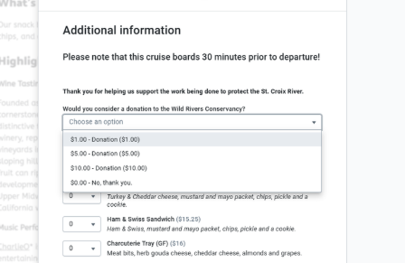

Social Media Discussions:
- Starting up a Towns of Pool 2 segment on social media – anyone have suggestions for next month and/or willing to snap a bunch of cool photos?

Action Items:
Alyssa:
- Put up a post on Facebook requesting an enclosed trailer as a donation
- Look into Airbnb’s along the river for a donation for the online auction
- Once the website is fully transitioned, I’ll make lots of updates
- Update the online merch store for final approval
- FOP2 Forum/Online Forum – will work with Luke on this

Cait:
- Put together a list of parades along pool 2, dates and how/when to sign up
- Ask Croation Hall about parking a trailer in their lot

Greg:
- Pick up Mankato tickets for the theater/Online Auction
- Draft a letter to the organization who is putting in a bike path/road that catches all the driftwood in Carver Co.
Financial Report:
- Fred is also looking at free general ledger programs for small businesses and nonprofits and is piloting two for us to hopefully take advantage of for accounting purposes.
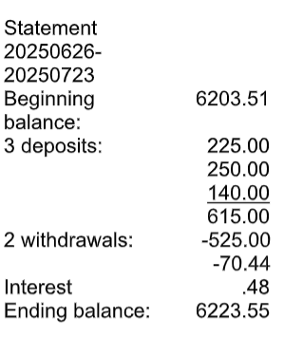
September 18th, 2025
- Meeting was adjourned at 7:50 PM
Minutes recorded by: Alyssa Stadtler – Executive Administrative Assistant

